I have chosen Storm_events_2015_data from the IBM Cognos Analytics and I considered bar graph to visualize the audience to whom I wanted to convey my story to. The story I have generated in the below visualization is convey total deaths of each state base on the source the data came from. To do that I have taken states on bars each bar represents the different states, next the length of the bar, which is total direct deaths, and finally the color of the bars represents the sources. This is visualization shows the color visual cues.

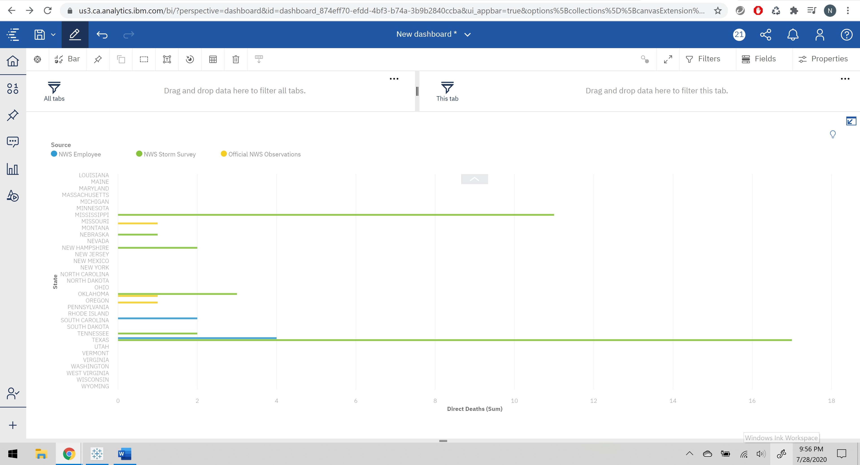

For the same audience I have considered to use different visual cue that is position. By using scatter plot, I have created this visualization below. This also tells us the same story for each state how many direct deaths registered from each source.

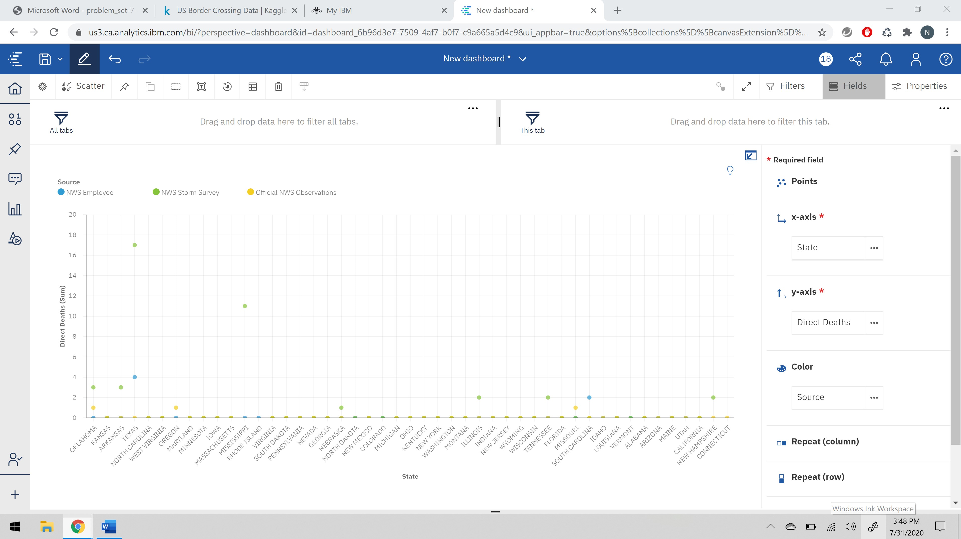

This representation is for shape visual cue for the same audience. By using packed bubbles, I have created this visualization which is bit clumsy and difficult to understand. For this audience this visualization is not clear.

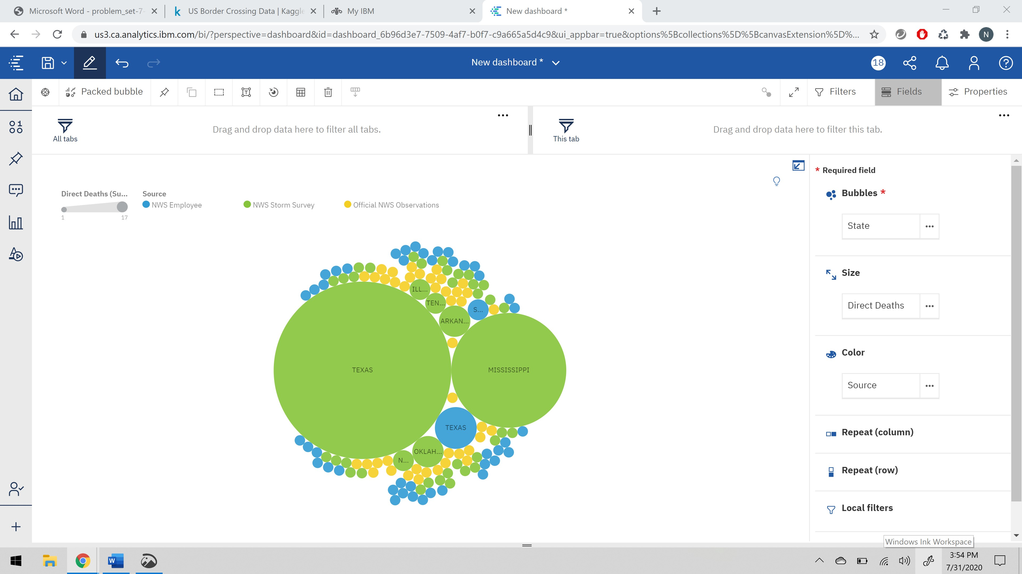

I have used different story to convey more information from the same dataset mentioned above. The story I have represented is for each state how much crop got damaged due to storm and property damage as well. To visualize this, I have taken state in x- axis, next crop damage in y- axis, and property damage is represented by the size of the bubble. This show the position visual cues. This visualization is quite difficult to understand.

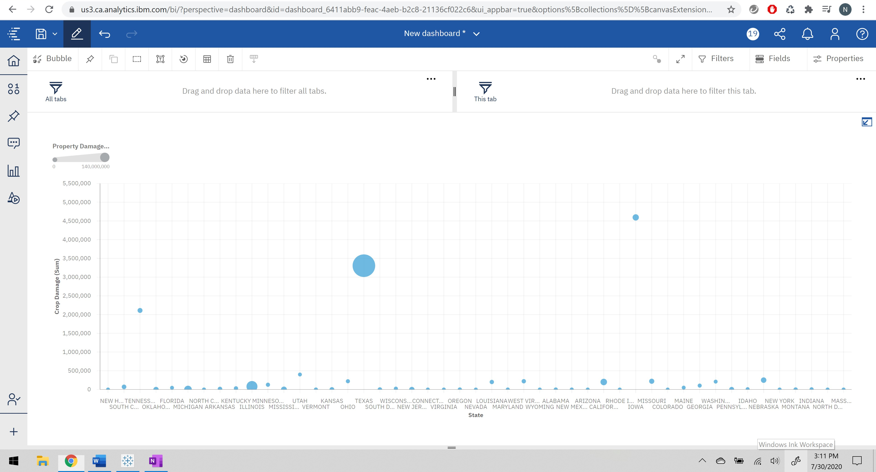

For the above audiences, I have considered different visualization to get better approach for the story to reach the larger audience. To do that I have chosen this packed bubble chart to get the information of the damage caused by the storm across different states. So, each bubble represents a state, then size of the bubble is representing crop damage and color shows us the property damage. This give use the insight of how shape visual cues help in presenting data to the audience in best possible way. This has better vision when compared to the above visualization.

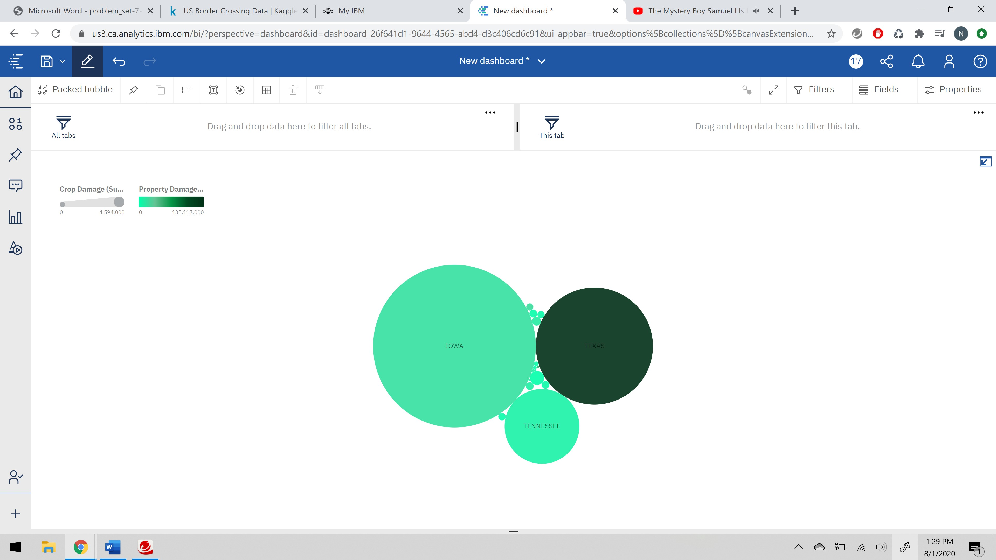

Let us consider the color visual cue and understand the story in a different way. I have used bar graph to tell the story of each states crop damage and property damage caused by the storm. This visualization tells us the information of state which is in y-axis and crop damage in x-axis which represents the length of the bar and variation in color indicates the property damage. This is also a good visualization which is clear and understandable.

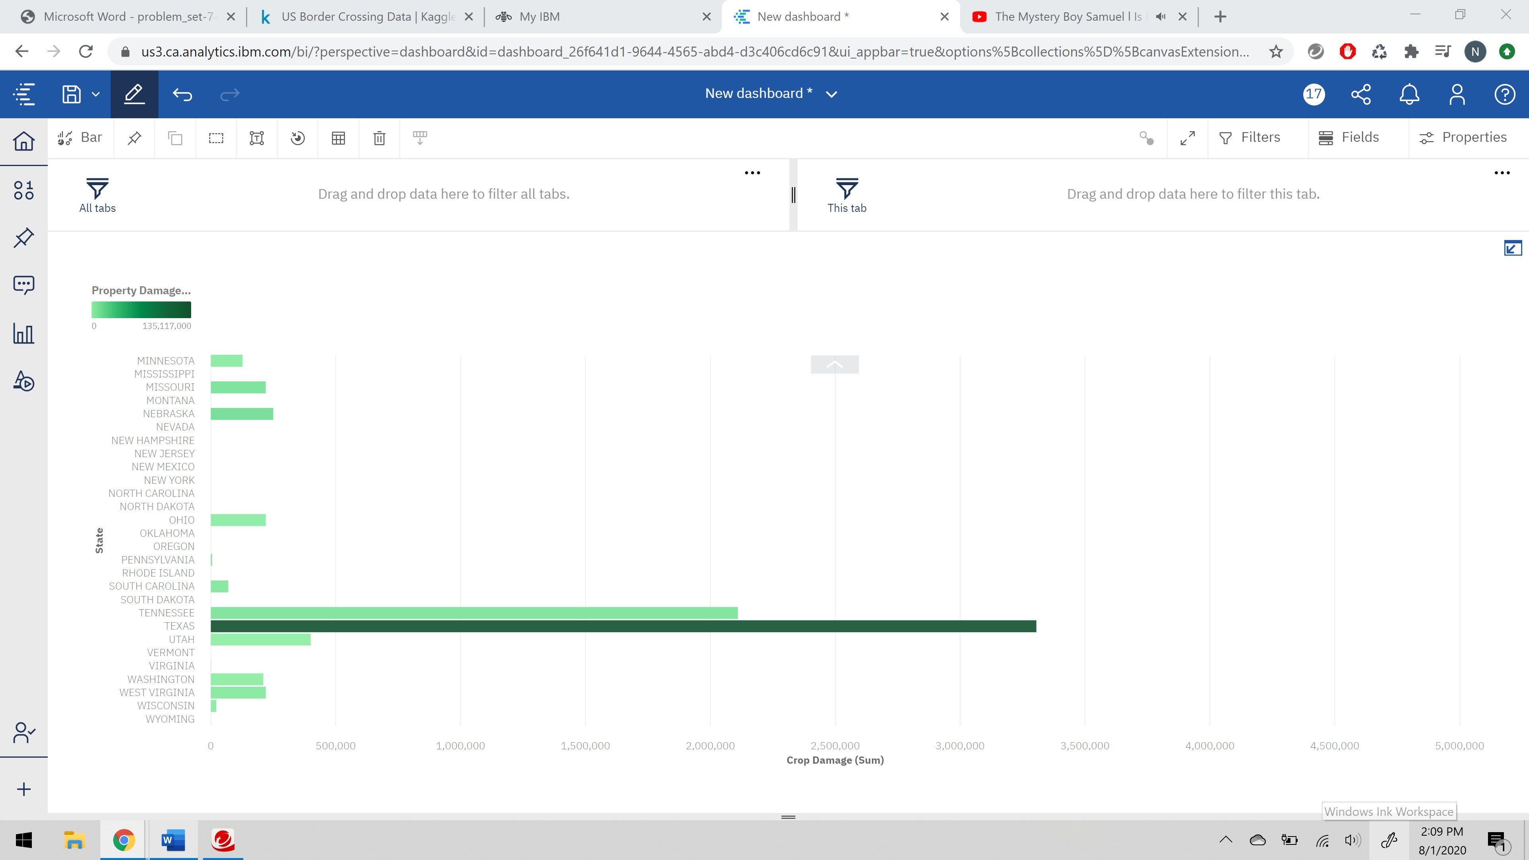

**Pros of data visualization using visual cues:**

1. Better understanding: this means understanding of the data set variables and elements present in the data.
2. Easy sharing of information: instead of sharing total data, we can share the visual info which will engage and convey the information in best possible way.
3. Accurate analysis: understanding data is difficult rather than understanding a visual representation of data.
4. Sales analysis: with the help of visualization a salesperson can understand the sales report of a product in a better way.
5. Finding relations between events: this is the crucial part of visualization, which is to draw relations between the variables and elements in the dataset.
6. Modification of data: cleaning data is very vital. To get good results this data modification and processing data is required.
7. Exploring opportunities and trends: finding a pattern in a dataset is very essential. This helps the company to understand the need of the hour and focus on improving them.
8. Geographical visualization: this help in pinpointing the daily analytical changes that is happening the datasets.

**Cons of data visualization using visual cues:**

1. It gives estimation not accuracy: This visualization gives us the prediction not the accurate value.
2. Biased: as the visualization considerations are done by human interface there might be a biased in considering the meaning correctly.
3. Lack of assistance: without assistance each audience interpret differently.
4. Improper design issue: if a visualized is designed improperly then that visualization will cause confusion.
5. Wrong focused people can skip core message: To get clarity of the explanation we tend to go off track from the core message. This may lead in skipping the data as well.

**References:**

<https://wisdomplexus.com/blogs/pros-cons-data-visualization/>